**PONDICHERRY UNIVERSITY**

**(A Central university)**



**SCHOOL OF ENGINEERING AND TECHNOLOGY DEPARTMENT OF COMPUTER SCIENCE**

**M.Sc. Computer Science**

NAME : MOHAMMED RIZVAN NT

REG. NO. : 23370036

SEMESTER : 3RD SEMESTER

SUBJECT : CSSC 513 - WEB TECHNOLOGY AND COMPUTER NETWORKS LAB

**PONDICHERRY UNIVERSITY**

**(A Central university)**



**SCHOOL OF ENGINEERING AND TECHNOLOGY DEPARTMENT OF COMPUTER SCIENCE**

**M.Sc. Computer Science**

PRACTICAL LAB RECORD

**BONAFIDE CERTIFICATE**

This is to certify that this is a Bonafide record of practical work done by **MOHAMMED RIZVAN NT**, having Reg. No. **23370036** semester - III from the month July 2024 to December 2024

**FACULTY IN-CHARGE**

SUBMITTED FOR THE PRACTICAL EXAM HELD ON:

**INTERNAL EXAMINER EXTERNAL EXAMINER**

# ONLINE BOOK STORE

## AIM:

To design a web page for online book store

# HOME PAGE

## SOURCE CODE:

<!DOCTYPE html>

<html lang="en">

<head>

<meta charset="UTF-8">

<meta name="viewport" content="width=device-width, initial-scale=1.0">

<title>Home Page</title>

<style>

body {

font-family: Arial, sans-serif; margin: 0;

padding: 0; display: flex;

flex-direction: column; min-height: 100vh; background-color: #f4f4f4;

}

.header {

background-color: #333; color: white;

padding: 15px; text-align: center;

}

.header img { height: 50px;

}

.header h1 { margin: 0;

}

.nav-bar {

margin-top: 10px;

}

.nav-bar a { color: white;

text-decoration: none; padding: 10px 20px; margin: 0 10px;

font-size: 16px;

}

.nav-bar a:hover { background-color: #444; border-radius: 4px;

}

.content-wrapper { display: flex; flex: 1;

}

.sidebar {

width: 200px;

background-color: #eaeaea; padding: 20px;

}

.sidebar a { display: block; padding: 10px; margin: 10px 0;

color: #333;

text-decoration: none; background-color: white; border-radius: 4px;

}

.sidebar a:hover { background-color: #bbb;

}

.main-content { flex: 1; padding: 20px;

background-color: #fff;

} </style>

</head>

<body>

<div class="header">

<img src="logo.png" alt="Logo"> <!-- Replace with your logo --><br><br>

<h1>ONLINE BOOK STORE</h1><br>

<div class="nav-bar">

<a href="homepage.html" target="main-content">Home</a>

<a href="login.html" target="main-content">Login</a>

<a href="registration.html" target="main-content">Registration</a>

<a href="catalogue.html" target="main-content">Catalogue</a>

<a href="cart.html" target="main-content">Cart</a>

</div>

</div>

<div class="content-wrapper">

<div class="sidebar">

<a href="cse_catalogue.html" >CSE</a>

<a href="ece_catalogue.html">ECE</a>

<a href="eee_catalogue.html">EEE</a>

<a href="civil_catalogue.html">CIVIL</a>

</div>

<div class="main-content" id="main-content">

<h2 style="font-size: 20px;">Welcome to the Online Bookstore</h2><br><br>

<p style="font-size: 30px;">Here you can find various books from different departments like CSE, ECE, EEE, and CIVIL.<br> Select a department from the left menu to view the catalogue of books available for that department.</p>

</div>

</div>

</body>

</html>

**OUTPUT:**

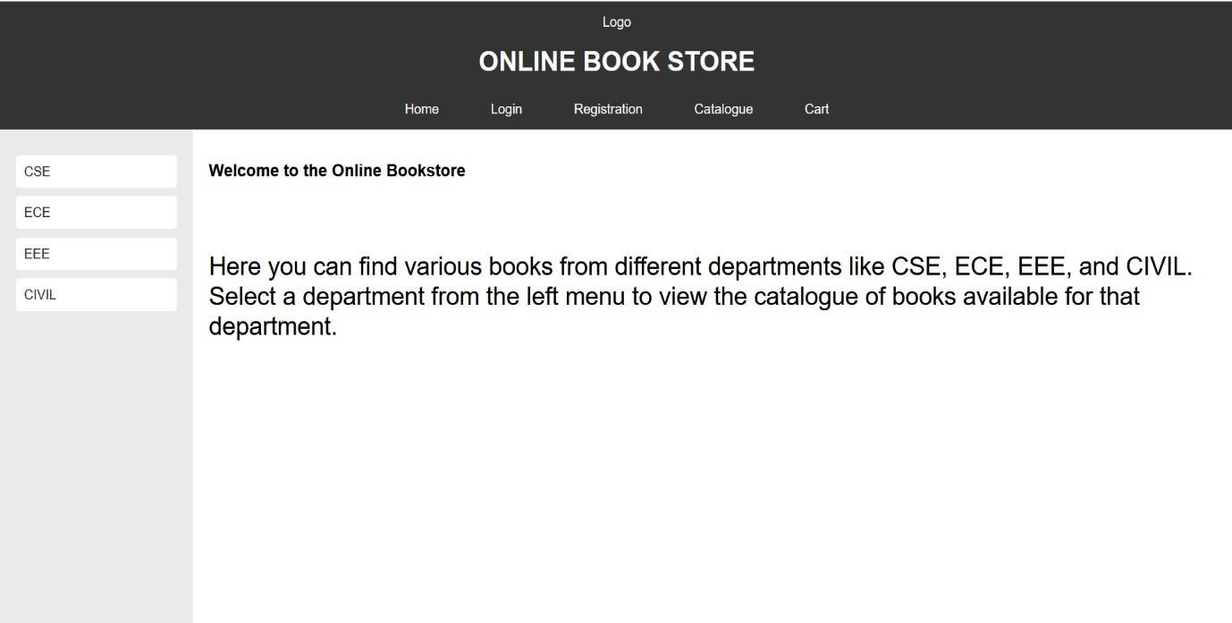

# LOGIN PAGE

## SOURCE CODE : -

<!DOCTYPE html>

<html lang="en">

<head>

<meta charset="UTF-8">

<meta name="viewport" content="width=device-width, initial-scale=1.0">

<title>Login Page</title>

<style>

body {

font-family: Arial, sans-serif; margin: 0;

padding: 0;

background-color: #f4f4f4; display: flex;

flex-direction: column; min-height: 100vh;

}

.header {

background-color: #333; color: white;

padding: 15px; text-align: center;

}

.header img {

height: 50px;

}

.header h1 { margin: 0;

}

.nav-bar {

margin-top: 10px;

}

.nav-bar a { color: white;

text-decoration: none; padding: 10px 20px; margin: 0 10px;

font-size: 16px;

}

.nav-bar a:hover { background-color: #444; border-radius: 4px;

}

.content-wrapper { display: flex; flex: 1;

}

.sidebar { width: 200px;

background-color: #eaeaea; padding: 20px;

height: 100vh; /* Make sidebar full height */

box-sizing: border-box;

}

.sidebar a { display: block; padding: 10px; margin: 10px 0;

color: #333;

text-decoration: none; background-color: #ffffff; border-radius: 4px;

}

.sidebar a:hover { background-color: #bbb;

}

.login-form { flex: 1; padding: 20px;

background-color: #fff; border-radius: 4px;

box-shadow: 0 0 10px rgba(0, 0, 0, 0.1);

}

.login-form h2 { margin-top: 0;

}

.login-form label { display: block; margin: 10px 0 5px; font-size: 14px;

color: #333;

}

.login-form input[type="text"],

.login-form input[type="password"] { width: 100%;

padding: 10px; margin: 5px 0 15px; border: 1px solid #ccc; border-radius: 4px;

}

.login-form button { padding: 10px 20px;

background-color: #4CAF50; color: white;

border: none; border-radius: 4px; cursor: pointer;

}

.login-form button:hover { background-color: #45a049;

}

.login-form input[type="reset"] { padding: 10px 20px; background-color: #f44336; color: white;

border: none; border-radius: 4px; cursor: pointer;

}

.login-form input[type="reset"]:hover { background-color: #e53935;

}

</style>

</head>

<body>

<div class="header">

<img src="logo.png" alt="Logo"> br><br>

<h1>ONLINE BOOK STORE</h1><BR>

<div class="nav-bar">

<a href="homepage.html" target="main-content">Home</a>

<a href="login.html" target="main-content">Login</a>

<a href="registration.html" target="main-content">Registration</a>

<a href="catalogue.html" target="main-content">Catalogue</a>

<a href="cart.html" target="main-content">Cart</a>

</div>

</div>

<div class="content-wrapper">

<div class="sidebar">

<a href="cse_catalogue.html" >CSE</a>

<a href="ece_catalogue.html" >ECE</a>

<a href="eee_catalogue.html" >EEE</a>

<a href="civil_catalogue.html">CIVIL</a>

</div>

<div class="login-form">

<h2>Login</h2><br>

<form action="login_process.html" method="POST">

<label for="username">Username:</label>

<input type="text" id="username" name="username" required>

<label for="password">Password:</label>

<input type="password" id="password" name="password" required>

<button type="submit">Submit</button>

<input type="reset" value="Reset">

</form>

</div>

</div>

</body>

</html>

**OUTPUT :-**

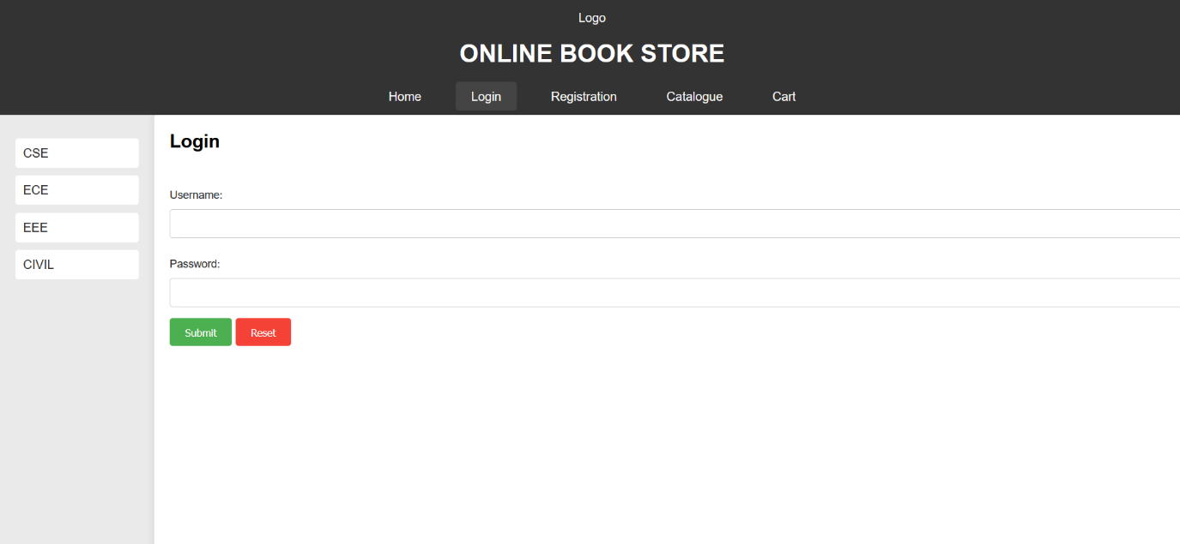

# REGISTRATION PAGE

## SOURCE CODE :-

<!DOCTYPE html>

<html lang="en">

<head>

<meta charset="UTF-8">

<meta name="viewport" content="width=device-width, initial-scale=1.0">

<title>Registration Form</title>

<style>

body {

font-family: Arial, sans-serif; margin: 0;

padding: 0;

background-color: #f4f4f4;

}

.container {

max-width: 600px; margin: 50px auto; background-color: white; padding: 20px;

border-radius: 8px;

box-shadow: 0 0 10px rgba(0, 0, 0, 0.1);

}

h2 {

text-align: center; color: #333;

}

label {

display: block; margin-top: 10px; color: #333;

}

input[type="text"], input[type="password"], input[type="email"], textarea, select

{

width: 100%; padding: 10px; margin-top: 5px; margin-bottom: 15px; border: 1px solid #ccc; border-radius: 4px;

}

input[type="radio"], input[type="checkbox"] { margin-right: 10px;

}

.button {

background-color: #4CAF50; color: white;

padding: 12px 20px; border: none; border-radius: 4px; cursor: pointer; width: 100%;

}

.button:hover {

background-color: #45a049;

}

.form-group {

margin-bottom: 15px;

}

</style>

</head>

<body>

<div class="container">

<h2>Registration Form</h2>

<form action="#" method="POST">

<div class="form-group">

<label for="name">Name</label>

<input type="text" id="name" name="name" required>

</div>

<div class="form-group">

<label for="password">Password</label>

<input type="password" id="password" name="password" required>

</div>

<div class="form-group">

<label for="email">E-mail ID</label>

<input type="email" id="email" name="email" required>

</div>

<div class="form-group">

<label for="phone">Phone Number</label>

<input type="text" id="phone" name="phone" required>

</div>

<div class="form-group">

<label>Sex</label>

<input type="radio" id="male" name="sex" value="Male" required>

<label for="male">Male</label>

<input type="radio" id="female" name="sex" value="Female">

<label for="female">Female</label>

<input type="radio" id="other" name="sex" value="Other">

<label for="other">Other</label>

</div>

<div class="form-group">

<label for="dob">Date of Birth</label>

<select id="day" name="day" required>

<option value="">Day</option>

<option value="1">1</option>

<option value="2">2</option>

<option value="3">3</option>

<!-- Add all days up to 31 -->

</select>

<select id="month" name="month" required>

<option value="">Month</option>

<option value="1">January</option>

<option value="2">February</option>

<option value="3">March</option>

</select>

<select id="year" name="year" required>

<option value="">Year</option>

<!-- Add years -->

<option value="2000">2000</option>

<option value="1999">1999</option>

</select>

</div>

<div class="form-group">

<label>Languages Known</label>

<input type="checkbox" id="english" name="languages" value="English">

<label for="english">English</label>

<input type="checkbox" id="telugu" name="languages" value="Telugu">

<label for="telugu">Telugu</label>

<input type="checkbox" id="hindi" name="languages" value="Hindi">

<label for="hindi">Hindi</label>

<input type="checkbox" id="tamil" name="languages" value="Tamil">

<label for="tamil">Tamil</label>

</div>

<div class="form-group">

<label for="address">Address</label>

<textarea id="address" name="address" rows="4" required></textarea>

</div>

<button type="submit" class="button">Register</button>

</form>

</div>

</body>

</html>

**OUTPUT:-**

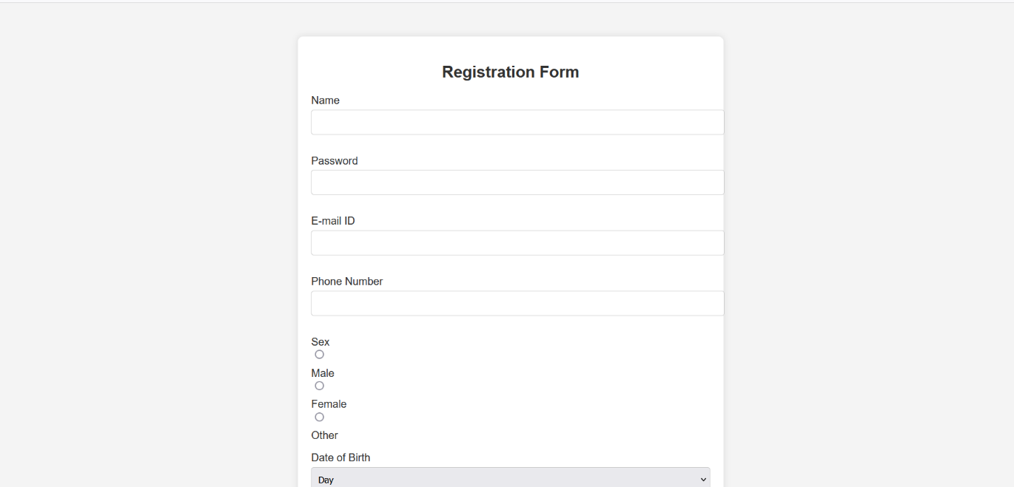

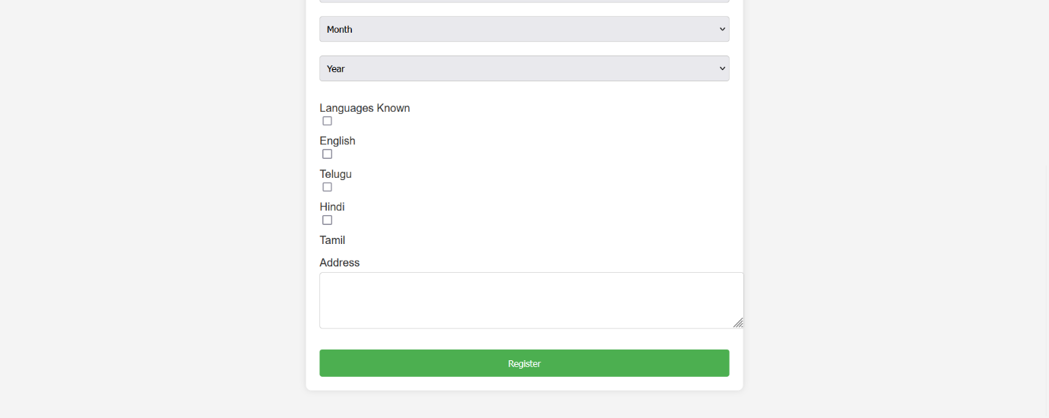

# CATALOGUE PAGE

## SOURCE CODE:

<!DOCTYPE html>

<html lang="en">

<head>

<meta charset="UTF-8">

<meta name="viewport" content="width=device-width, initial-scale=1.0">

<title>Catalogue Page</title>

<style>

body {

font-family: Arial, sans-serif; margin: 0;

padding: 0;

background-color: #f4f4f4;

}

.header {

background-color: #333; color: white;

padding: 15px; text-align: center;

}

.header img {

height: 50px; /* Adjust according to your logo size */

}

.header h1 { margin: 0;

}

.nav-bar {

margin-top: 10px;

}

.nav-bar a { color: white;

text-decoration: none; padding: 10px 20px; margin: 0 10px;

font-size: 16px;

}

.nav-bar a:hover { background-color: #444; border-radius: 4px;

}

.content-wrapper { display: flex; padding: 20px;

}

.sidebar { width: 200px;

background-color: #eaeaea; padding: 20px;

height: 100vh;

box-sizing: border-box;

}

.sidebar a { display: block; padding: 10px; margin: 10px 0;

color: #333;

text-decoration: none; background-color: #ffffff; border-radius: 4px;

}

.sidebar a:hover { background-color: #bbb;

}

.catalogue { flex: 1;

padding: 20px; background-color: #fff; border-radius: 4px;

box-shadow: 0 0 10px rgba(0, 0, 0, 0.1);

}

.catalogue h2 { margin-top: 0;

}

table {

width: 100%;

border-collapse: collapse; margin-top: 20px;

}

table, th, td {

border: 1px solid #ddd;

}

th, td {

padding: 10px; text-align: left;

}

th {

background-color: #f2f2f2;

}

.book-img { width: 100px; height: 150px; object-fit: cover;

}

.add-to-cart {

background-color: #4CAF50; color: white;

border: none; padding: 8px 16px; cursor: pointer; border-radius: 4px;

}

</style>

</head>

<body>

<div class="header">

<img src="logo.png" alt="Logo"> <br><br>

<h1>ONLINE BOOK STORE</h1><br>

<div class="nav-bar">

<a href="homepage.html" >Home</a>

<a href="login.html" >Login</a>

<a href="registration.html">Registration</a>

<a href="catalogue.html" >Catalogue</a>

<a href="cart.html">Cart</a>

</div>

</div>

<div class="content-wrapper">

<div class="sidebar">

<a href="cse_catalogue.html" >CSE</a>

<a href="ece_catalogue.html" >ECE</a>

<a href="eee_catalogue.html" >EEE</a>

<a href="civil_catalogue.html">CIVIL</a>

</div>

<div class="catalogue">

<h2>Books Catalogue</h2>

<table>

<thead>

<tr>

<th>Book</th>

<th>Author</th>

<th>Publisher</th>

<th>Price</th>

<th>Action</th>

</tr>

</thead>

<tbody>

<tr>

<td>

<p>XML Bible</p>

</td>

<td>Winston</td>

<td>Wiley</td>

<td>Rs 40.5</td>

<td><button class="add-to-cart">Add to Cart</button></td>

</tr>

<tr>

<td>

<p>AI</p>

</td>

<td>S. Russell</td>

<td>Princeton Hall</td>

<td>Rs 63</td>

<td><button class="add-to-cart">Add to Cart</button></td>

</tr>

<tr>

<td>

<p>Java 2</p>

</td>

<td>Watson</td>

<td>BPB Publications</td>

<td>Rs 35.5</td>

<td><button class="add-to-cart">Add to Cart</button></td>

</tr>

<tr>

<td>

<p>HTML in 24 Hours</p>

</td>

<td>Sam Peter</td>

<td>Sam Publications</td>

<td>Rs 50</td>

<td><button class="add-to-cart">Add to Cart</button></td>

</tr>

</div>

</div>

</tbody>

</table>

</body>

</html>

**OUTPUT : -**

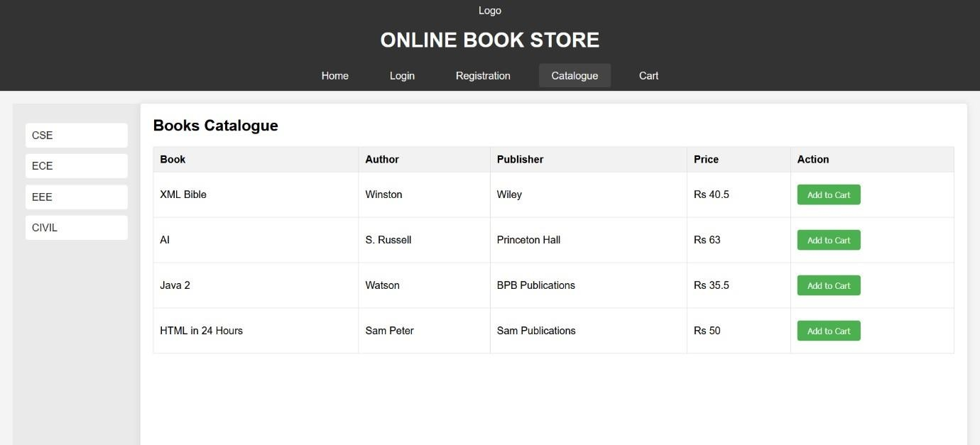

# CART PAGE

## SOURCE CODE:

<!DOCTYPE html>

<html lang="en">

<head>

<meta charset="UTF-8">

<meta name="viewport" content="width=device-width, initial-scale=1.0">

<title>Cart Page</title>

<style>

body {

font-family: Arial, sans-serif; margin: 0;

padding: 0;

background-color: #f4f4f4;

}

.header {

background-color:#333;; color: white;

padding: 10px 20px; text-align: center;

}

.nav {

text-align: center; margin-top: 10px;

background-color: #fffafa; padding: 10px;

}

.nav a {

color: rgb(0, 0, 0); text-decoration: none; margin: 0 20px;

}

.container { margin: 20px;

}

table {

width: 100%;

border-collapse: collapse; margin-top: 20px;

}

table, th, td {

border: 1px solid #ccc;

}

th, td {

padding: 12px; text-align: left;

}

th {

background-color: #f2f2f2;

}

.total {

margin-top: 20px; text-align: right; font-size: 18px; font-weight: bold;

}

</style>

</head>

<body>

<div class="header">

<img src="logo.png" alt="Logo" height="50"> <!-- Replace with your logo -->

<h1>ONLINE BOOK STORE</h1>

</div>

<div class="nav">

<a href="home.html">Home</a>

<a href="login.html">Login</a>

<a href="registration.html">Registration</a>

<a href="catalogue.html">Catalogue</a>

<a href="cart.html">Cart</a>

</div>

<div class="container">

<h2>Your Cart</h2>

<table>

<thead>

<tr>

<th>Book Name</th>

<th>Price</th>

<th>Quantity</th>

<th>Amount</th>

</tr>

</thead>

<tbody>

<tr>

<td>CSE Java</td>

<td>$35.5</td>

<td>2</td>

<td>$70</td>

</tr>

<tr>

<td>ECE XML Bible</td>

<td>$40.5</td>

<td>1</td>

<td>$40.5</td>

</tr>

</tbody>

</table>

<div class="total">

<p>Total Amount: $110.5</p>

</div>

</div>

</body>

</html>

**OUTPUT:-**

